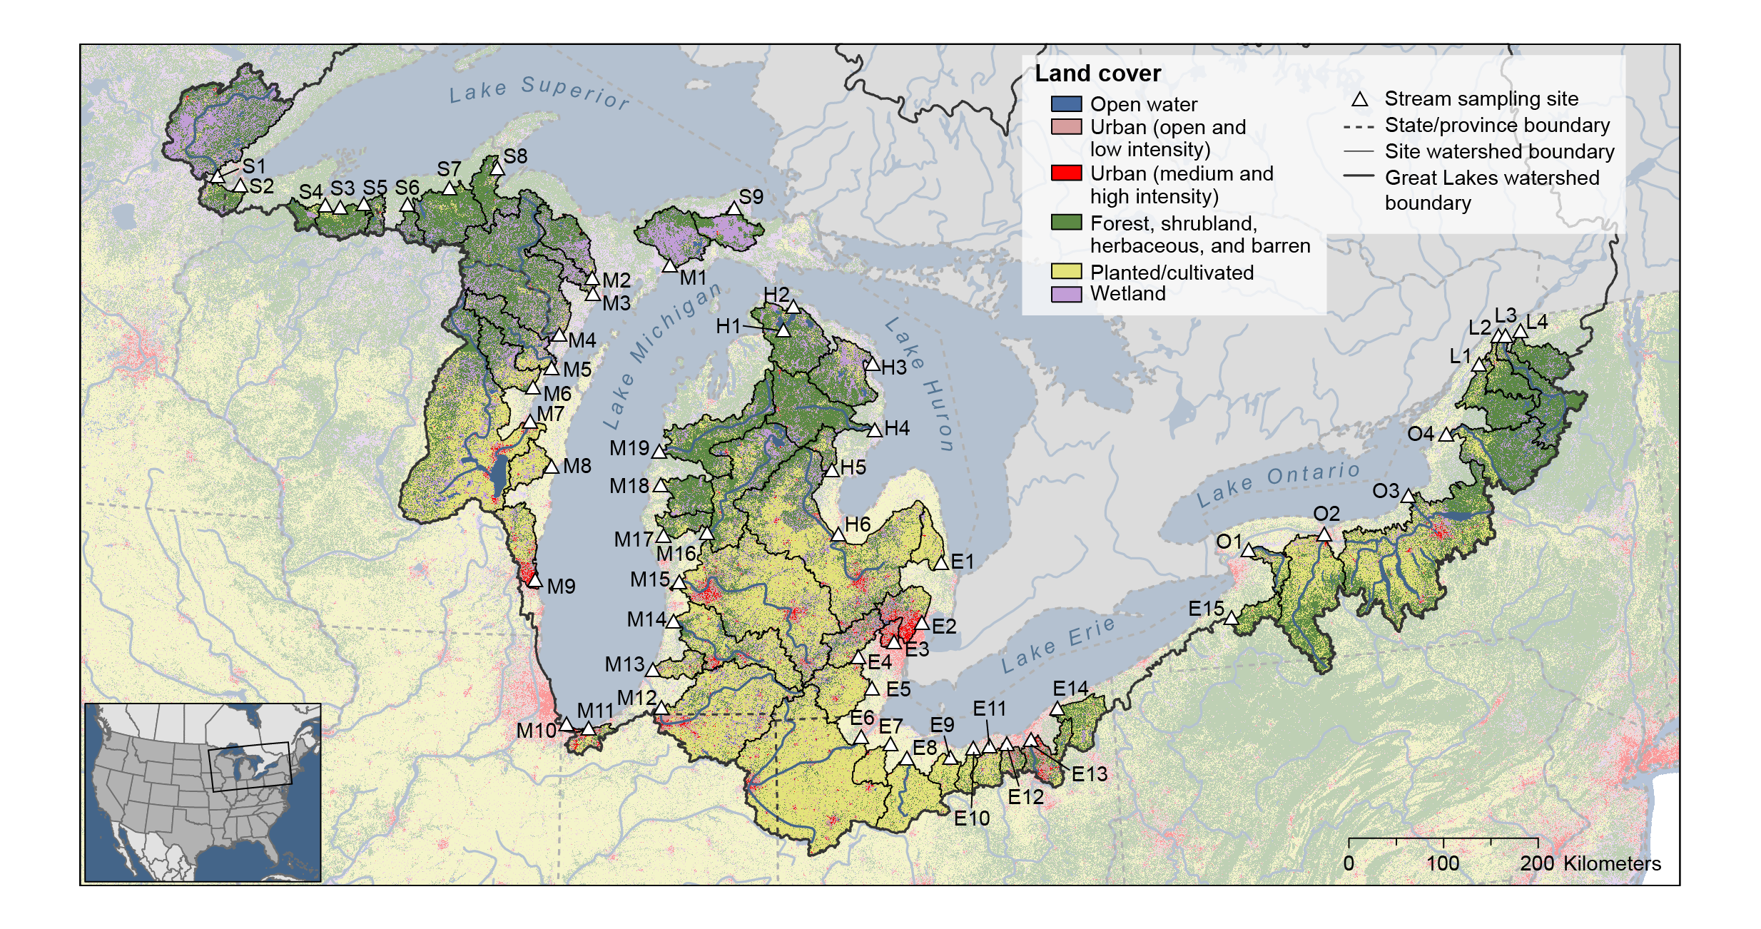

Figure SI-1. Location of water sampling locations, watershed boundaries, and watershed land-uses. Map IDs are defined in Table SI-1.